|  |
| --- |
| *CometBites* |
| **Project Plan** |
| **SE 6387 Advanced Software Engineering Project**  **R.Z. Wenkstern**    ***Date*** |

|  |
| --- |
| **Group *CometBites*** |
| **Ronaldo Goncalves Junior**  **rxp152830** |
| **Twinkle Sharma**  **txs151730** |
| **Keerthi Santhalingam**  **kxs142830** |
| **Ramakrishnan Sathyavageeswaran**  **rxs142530** |

# Revision History

|  |  |  |  |
| --- | --- | --- | --- |
| **Version** | **Date** | **Description** | **Authors** |
| 0.1 | 9/15/16 | Completed initial draft | Ram, Ronaldo |
| 0.2 | 9/20/16 | Added Work Plan – Team Sprint Activities | Ram |

Contents

Revision History 2

1. 1. Overview 1

1.1 Purpose, scope and objectives 1

1.2 Assumptions and constraints 1

1.2.1 Assumptions 1

1.2.2 Dependencies 1

1.2.3 Constraints 1

1.3 Project deliverables 2

1.4 Schedule and budget summary 3

2. Project Organization 3

2.1. Roles and Responsibilities 3

3. Managerial process plan 3

3.1 Start-up plan 3

3.1.1 Estimation plan 3

3.1.2 Staffing plan 3

3.1.3 Resource acquisition plan 3

3.2 Work plan 3

3.2.1 Work activities 3

3.2.2 Schedule/Resource/Budget allocation 4

3.3 Risk management plan 5

4. Technical process plans 5

4.1 Process model 5

4.2 Methods, tools and techniques 5

4.3 Infrastructure plan 6

4.4 Product acceptance plan 6

5. Supporting process plans 6

5.1 Configuration management plan 6

5.2 Test plan 6

5.3 Documentation plan 6

5.4 Quality assurance plan 6

Appendix A: Glossary 7

Appendix B: References 8

# 1. 1. Overview

Students have a routine that depends on their institution’s schedule, which affects most activities on campus. That is also true when it comes to eating. In the particular case of those that attend the University of Texas at Dallas (UTD), huge lines must be faced in order to eat during peak hours (between 11a.m and 1p.m). Encountering this reality, the students are left with limited options. They must wait a certain period of time in order to have a meal, or try to come back later. Unfortunately, for both students and food establishments, there is also the option to give up.

This document describes the planning involved for this project. This section describes the overview aspects of the project. The next section describes the organization, followed by the managerial process plan and the technical process plan. Subsequently, the last section shows other process planning, which represent the supporting aspects of the project.

## Purpose, scope and objectives

Our concept is a solution focused to overcome one of the major issues faced by the students of UTD every day and to upgrade the existing system to make their lives easier. The system needs to be revisited and rechecked considering the amount of growing lines at each food joint during the peak hours in our comet cafeteria. This is a game-changer constructed to overcome the long queues during the hungry times. The customer uses the mobile application to place order, check the wait time, and other features provided by the product. Once an order is placed, the software system sends the information to the kitchen for preparation. Later, when the order is ready, the kitchen updates the status of the order and sends the food for pickup. Once the update takes place, the customer gets notified and can pick up his food from the counter.

## 1.2 Assumptions and constraints

For our project we consider several assumptions and constraints which were taken into account.

### 1.2.1 Assumptions

* Team members are expected to have expertise in software development.
* Team members are expected to know the agile methodology.
* Project members will allocate enough time according to projected schedule in order to complete allocated tasks and objectives before the deadlines.
* UTD Dining Service will respond and interact with team in a timely manner (within 5 business days).

### 1.2.2 Dependencies

* Team member’s availability due to multiple simultaneous projects.
* Each sprint depends directly on the successful completion of the previous sprints.
* Stakeholders are available for project review.
* Effective face-to-face communication within the team.

### 1.2.3 Constraints

* The project must be finished on or before December 2nd.
* The project is subjected to UTD Dining Service business decisions and regulations.
* The project is subjected to UTD Dining Service restricted budget allocation and policies on hardware acquisition.

## 1.3 Project deliverables

Project deliverables are as follows:

* Deliverable 1 (Due in: 9/06/2016)
  + Executive Summary
  + Feasibility Analysis
  + Vision Document
* Deliverable 2 (Due in: 9/16/2016)
  + Project Plan
  + Requirements Analysis: UC Diagrams
  + Project Status Report
* Deliverable 3 (Due in: 10/16/2016)
  + Presentation: Use Case Diagram, SSD, Domain Model
  + Updated deliverables
  + Requirements Analysis Document: UCDs, UC Prioritization, UC1 Fully Dressed, UC1 SSD, Operational Contracts (for the most important operations)
  + Supplementary Specification
  + Project Status Report
* Deliverable 4 (Due in: 10/20/2016)
  + Updated deliverables
  + System High Level Architecture
  + UI Design (sketches)
  + DB Design (tables)
  + Project Status Report
* Deliverable 5.1 (Due in: 10/27/2016)
  + Presentation: Demo (UC1)
  + Updated deliverables
  + System Detailed Design Document
  + UC1 initial Implementation
  + Project Status Report.
* Deliverable 5.2 (Due in: 11/3/2016)
  + Presentation: Demo (UC1+extensions)
  + Updated deliverables
  + UC1 + extensions Implementation
  + Project Status Report
* Deliverable 6 (Due in: TBA)
  + Presentation: UC2 Analysis and Design
  + Updated deliverables
  + Project Status Report
* Deliverable 7 (Due in: TBA)
  + Presentation: Demo (UC2)
  + Updated deliverables
  + Project Status Report.
* Final Deliverable (Due in: 12/2/2016)
  + Presentation: Live Demo + Video
  + Updated deliverables
  + Complete Code
  + Project Status Report.

## 1.4 Schedule and budget summary

Schedule is based on four major milestones:

Table 1: Schedule summary for major project milestones.

|  |  |  |
| --- | --- | --- |
| **Name** | **Start Date** | **End Date** |
| Requirement Analysis | 9/16/2016 | 10/10/2016 |
| Product Design | 10/11/2016 | 11/16/2016 |
| Release 1.1 | 10/24/2016 | 11/2/2016 |
| Release 1.2 | 11/3/3016 | 12/1/2016 |

Please note that the process model used is agile. The start and end dates for each of the milestones might include multiple iterations. For a more detailed information on schedule and budget, please refer to sections 3.2.1 and 3.2.2 respectively.

# 2. Project Organization

Project organization is structured as shown in Figure 1. The project manager coordinates all activities of the project, which includes all roles except the developer. The activities performed by the system analyst, the requirements analyst and the test analyst are subjected to auditing by the quality analyst. In addition to that, they must follow the infrastructure and rules set by the configuration manager. Finally, the system analyst is responsible for coordinating activities related to the software system development performed by developers.

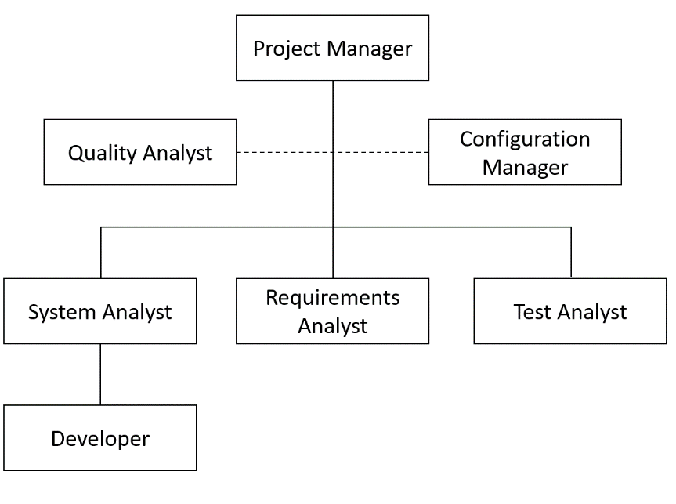

Figure 1: Project organization structure.

## 2.1. Roles and Responsibilities

Table 1 presents the information of the team members with respect to their roles and responsibilities. Note that each team member has multiple roles and responsibilities due to the limited number of members. Section 3.1.2 describes these resources according to other details.

Table 2: Roles and responsibilities.

|  |  |  |  |
| --- | --- | --- | --- |
| **Name** | **Roles and Responsibilities** | **Daily Workload** | **Contact Information** |
| Ronaldo Goncalves Junior | Project Manager, Requirements Analyst | 2h | rxp152830@utdallas.edu |
| Twinkle Sharma | Quality Analyst, Developer | 2h | txs151730@utdallas.edu |
| Ramakrishnan Sathyavageeswaran | Configuration Manager, Developer | 2h | rxs142530@utdallas.edu |
| Keerthi Santhalingam | System Analyst, Test Analyst | 2h | kxs142830@utdallas.edu |

# 3. Managerial process plan

## 3.1 Start-up plan

### 3.1.1 Estimation plan

Final costs and pricing for the software system will be dictated by the type and the number of devices to be used since the application is going to run on the user’s smartphone. A single full kiosk price goes from $100.00 up to $10,000.00 or more. The following table shows the pricing list for a single full kiosk [6].

|  |  |  |
| --- | --- | --- |
| Item | Description | Average price |
| Full Kiosk | Touchscreen, CPU, Enclosure (only) | $3,440 |
| Touchscreen | 17" lcd | $1,180 |
| Touchscreen | **15" lcd** | **$872** |
| Thermal Printer | Across all models | $630 |
| CPU | **With OS** | **$736** |
| Keyboard | Industrial | $334 |
| Software | **License** | **$400** |
| Software | Management (36 months) | $1,800 |
| Technical support | 24/7 (36 months) | $3,600 |
| Installation | **Full** | **$1,000** |
| Enclosure (only) | **Across all materials** | **$1,330** |
| UPS | Across all models | $114 |
| Card Reader | Across all models | $113 |
| Bill Validator | Across all models | $368 |
| Fully Loaded Kiosk | * | $13,383 |

A complete but economic setup (items in bold) might reduce the price of a single kiosk to $4,338. Alternatives that include only the standing (that supports a tablet), a minimal setup, can reduce the price even further to an average of $100. Although economically attractive, this minimal setup is prone to cease functioning in a short term, since the device is going to be used by a large number of users in a daily basis.

For the prototype, firstly, smartphones will be used to run the application. Secondly, a tablet will be used. It can simulate the usage of a kiosk closely, and the effort required to adapt the software system to run on a kiosk afterwards is considerably low. With economics options of $25 to $100, the tablet is technically, economically, and in terms of usability the best option for the device prototype.

### 3.1.2 Staffing plan

The table below (see Figure 2) presents the cost of the human resources involved in the project. It is important to mention that some resource names do not match their role exactly. Both Developer1 and 2 are of the Developer role, Development and Operation (DevOps) is of the Configuration Manager role, and Test Engineer refers to the Test Analyst role.

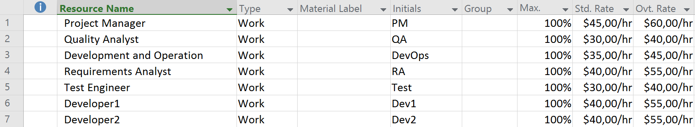

Figure 2: MS Project resource plan.

### 3.1.3 Resource acquisition plan

This project plan includes the development of a prototype and a final release which includes all functionalities of the proposed software system. For the prototype, there will be no acquisition of hardware, since the development team possesses the required hardware to develop the solution, that is, a tablet. For the fully functional solution, the acquisition of the kiosk will depend on the UTD Dining services budget allocation.

## 3.2 Work plan

### 3.2.1 Work activities and Schedule

The Work activities are done in Sprint (iterative fashion). Below are the detailed work activities performed in each iteration by the team.

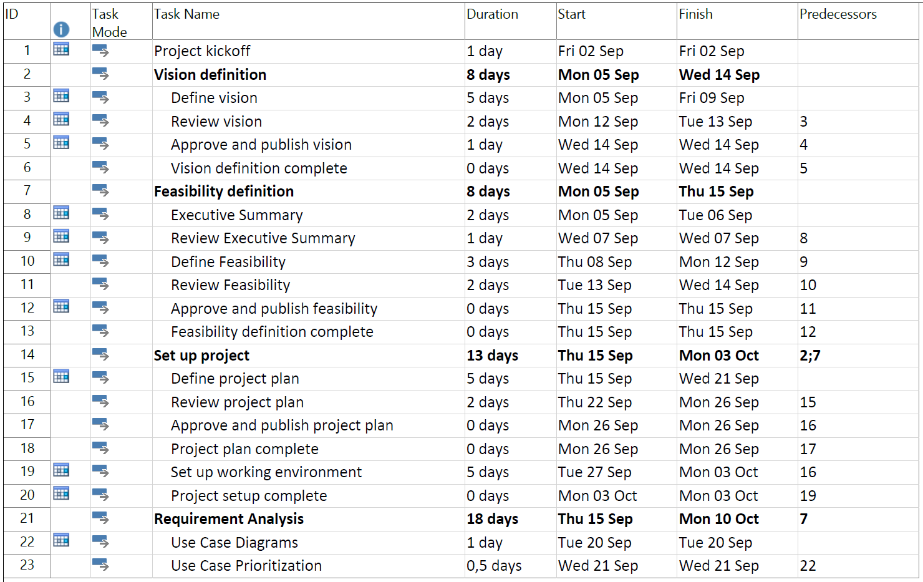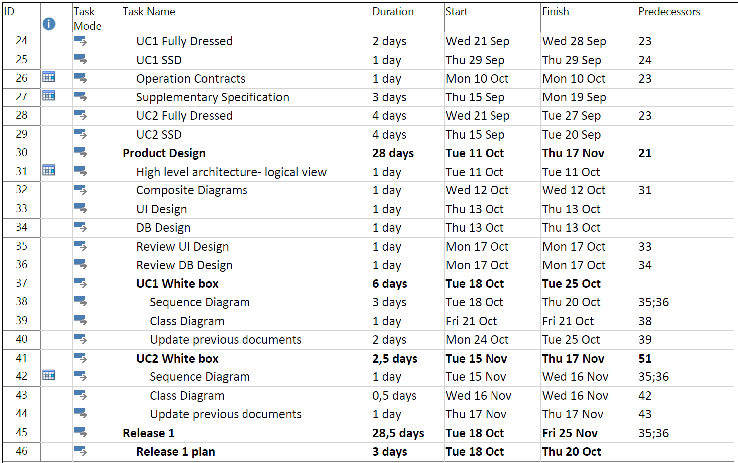

Figure 3: MS Project work breakdown structure (part 1).

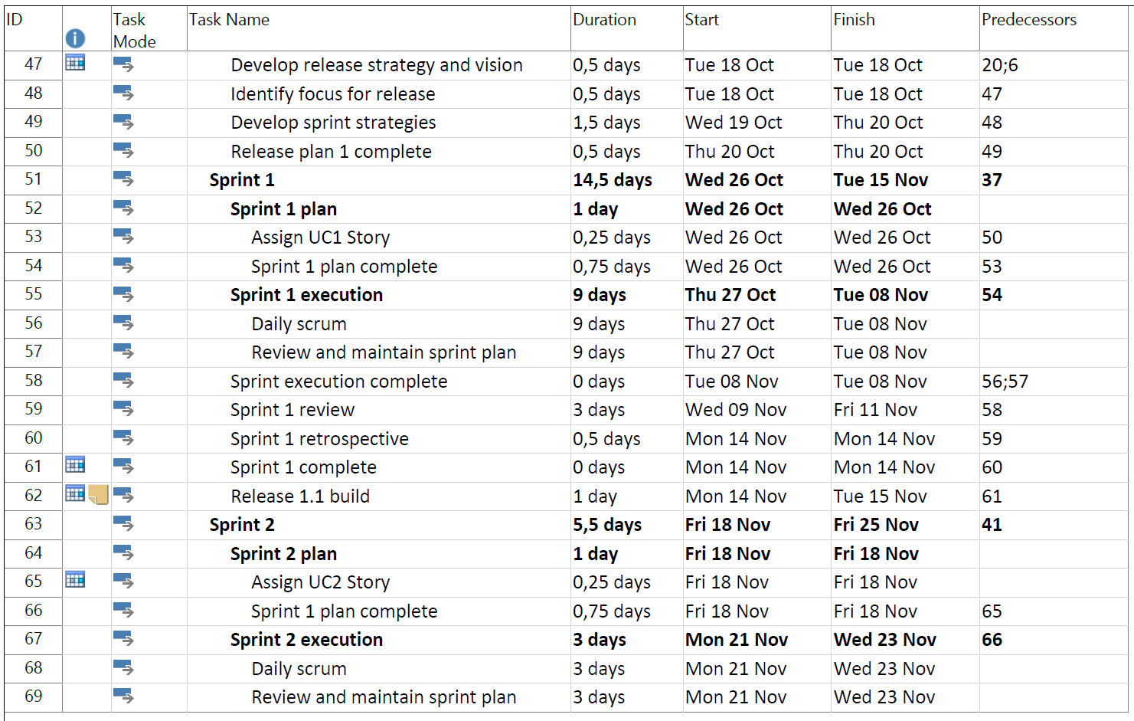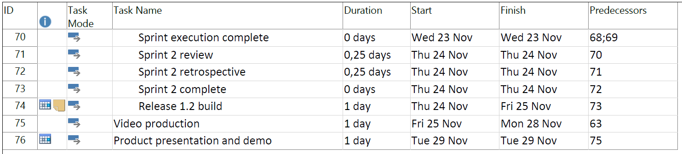

Figure 4: MS Project work breakdown structure (part 2).

## 3.3 Risk management plan

All the risks have been classified based on the following types

* People
* Technology
* Product
* Security
* Market

|  |  |  |  |  |
| --- | --- | --- | --- | --- |
| **Risk** | **Type** | **Risk level** | **Impact on Schedule** | **Risk Mitigation Plan** |
| Project scope  Misunderstanding | **People** | Medium | * Delays completion of tasks on time * Rework of documents which in turn increase the time for implementation * Documents end up being faulty | * Conduct brainstorming sessions to identify ideas * Conduct scrum meetings to pick tasks from the backlog |
| Changes in Schedule/deadlines | **Product** | Medium | * Since we use scrum methodology change in schedule impacts on the velocity of the team * It reduces the time for each sprint with an increase in product backlog | * Have sufficient buffer time to accommodate changes in schedules |
| Team member Technical Expertise | **Technology** | Low | * Affects velocity of each sprint resulting in late submission of the required documents * Multiple platforms: App and Kiosk | * Cross train within team so that all team members are on the same page |
| Team member’s Commitment to Project | **People** | High | * Team work is required in the project to complete all backlogs | * Motivate the team * Work with a common goal |
| Quality of the Product | **Product** | **High** | * Ensuring quality of the documents requires user participation which involves the timeline of the user which would greatly impact the schedule | * Iterative development helps in obtaining user feedback after each sprint ensuring high quality of the end product |
| Data Loss | **Security** | **High** | * The application consists of user personal information which pose as a high risk to security * Ensuring security will have a huge impact on the schedule | * Perform regular reviews * Test driven development |
| Changing Requirement | **Product** | **High** | * Change in requirements change the scope of the projects increasing the timelines thus affecting the deadline | * Agile methodology aides in accepting changing requirements * Scope creep is analyzed prior to the start of the project |

# 4. Technical process plans

## 4.1 Process model

Entire project will be following “Scrum”, an agile methodology as a method to complete the project work.

## 4.2 Methods, tools and techniques

The tools and applications used by the team for this project:

1. Document Development: MS Office Word, MS Office Powerpoint
2. Software Project Management: MS Project
3. Software Configuration Management: Github
4. Document Versioning: Github
5. Requirement Management Tool: IBM Rational DOORS
6. Software Design Tool: IBM Rhapsody, Adobe Photoshop
7. Testing Tool: Maveryx(Functional Testing), Junit(Unit testing)
8. Email: official communication medium to interact among team members
9. Microsoft Visio: UML creation
10. Gliffy: Domain Model Diagram
11. Dia: Tool to draw Structured Diagram
12. Prototype Development: Justinmind Tool, Balsamiq mockup 3
13. Meet up/Conversation: Library Study room/ Open lab, Google Hangouts, Whatsapp Group

## 4.3 Infrastructure plan

The system is going to interact with multiple types of hardware: kiosks, smartphones, and displays. These devices will change the environment where the software system will be deployed. The infrastructure plan for this project includes these changes in the environment.

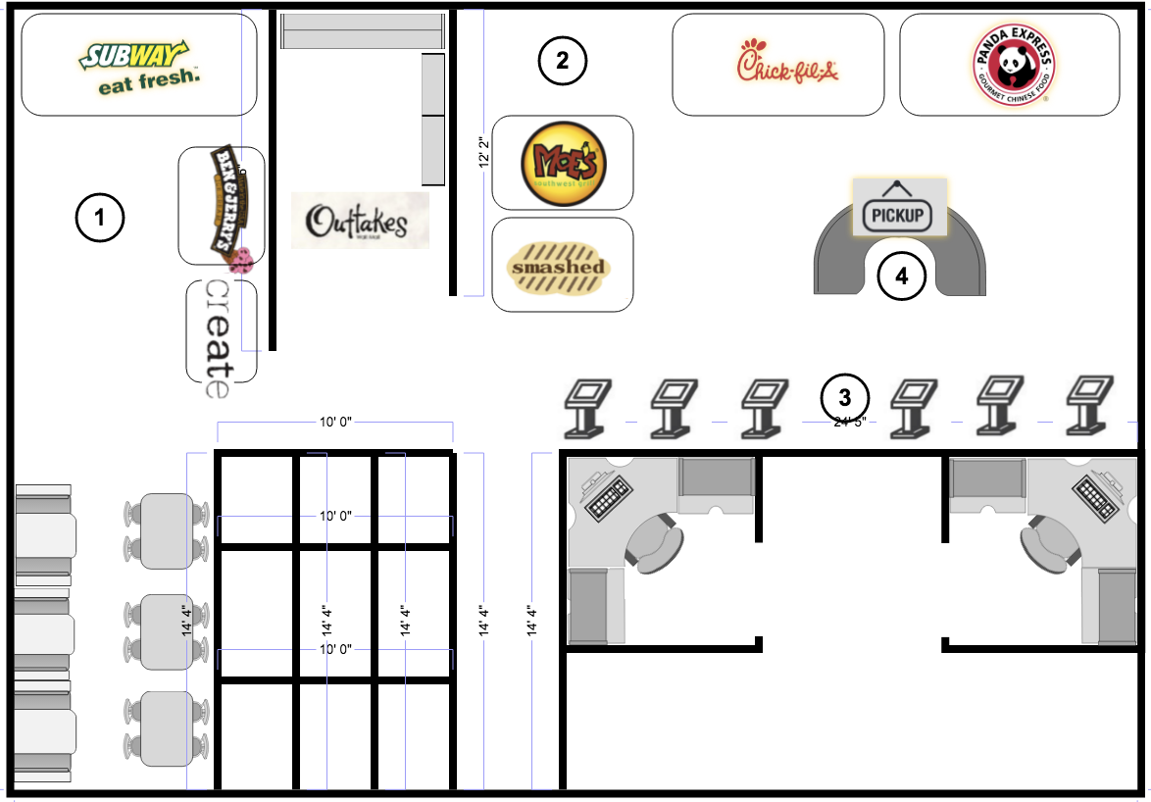

Figure 5: Dining environment after deployment of the software system.

Figure 2 illustrates the environment changes after the deployment of the solution. It is possible to identify two main locations where a customer can purchase food from[1]: Comet Café (area 1) and Student Union Food Court (area 2). Within these areas, there are mainly three restaurants that are affected by the long waiting lines problem. These are Subway, Chick-fil-A, and Panda Express. Note that due to space limitations, the kiosks will be placed in area 3. With the addition of the pickup process, the food joints will have to provide a pickup counter for the customers to pick up their orders. There are two locations where this counter can be placed. If the food joints agree to have a common location for their customers, the counter will be located at area 4. Since the food joints might want to handle their own orders separately, Figure 3 illustrates the alternative place for the pickup counters.

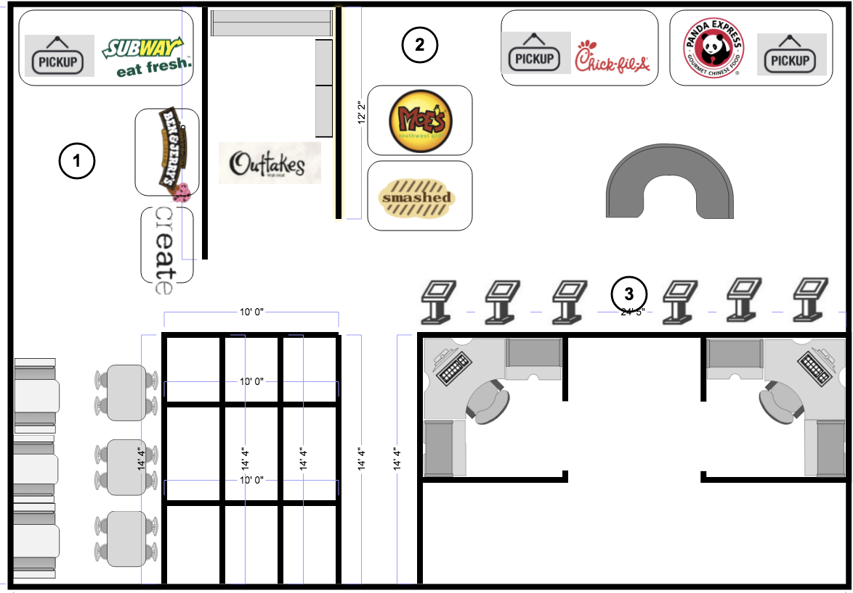

**Figure 3:** Alternative environment after deployment of the software system.

## 4.4 Product acceptance plan

This project includes the development of a prototype. This prototype will be used for verification purposes, and, subsequently, validated with the customer. Each sprint contains a release, namely Release 1.1 and Release 1.2.

The first release will include a product acceptance test in order to validate the prototype. Following this release, the second one will include a product acceptance test for the software system as a whole. That is, the fully functional system. For more information on the schedule, please see section 3 of this document.

# 5. Supporting process plans

TBD

## 5.1 Configuration management plan

For the Configuration management our team use GitHub to maintain both documents and the software application

## 5.2 Test plan

TBD

## 5.3 Documentation plan

TBD

## 5.4 Quality assurance plan

TBD

# Appendix A: Glossary

|  |  |
| --- | --- |
| **Term** | **Definition** |
|  |  |
|  |  |
|  |  |
|  |  |
|  |  |
|  |  |
|  |  |
|  |  |
|  |  |

# Appendix B: References

1. Dining: www.utdallas.edu/union/